Parties, Politics, and Political Participation NAME:
Mr. Faulhaber
“The Polarization Spiral” Article Review PER:
The Polarization Spiral: How the right's monomania and the left's Great Awokening feed each other
by Jonathan Haidt and Greg Lukianoff
Aug 17, 2022
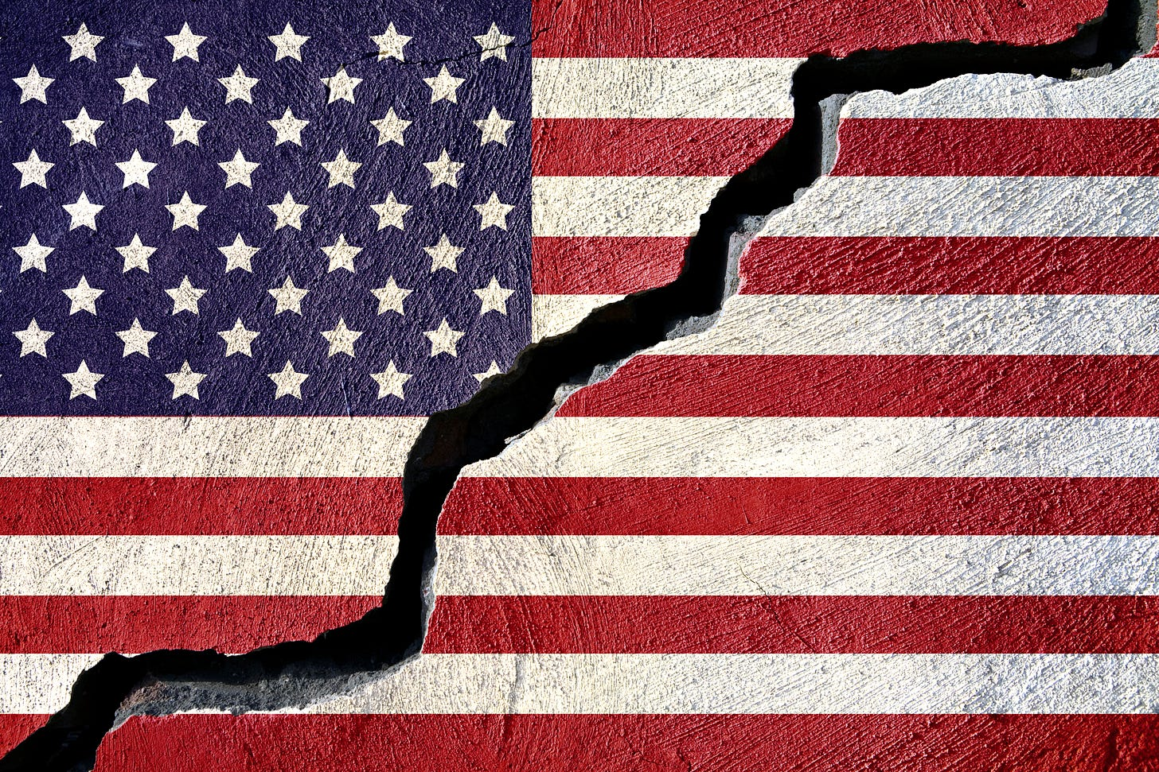

The early chapters of our book, The Coddling of the American Mind,¹ are about a set of destructive and illiberal ideas that emerged on American college campuses in the years 2014-2016. Because campuses lean decidedly left, these chapters are critical of ideas and practices associated with the left. But we worked hard to take a holistic and multi-faceted view of the problem, and we devoted a full chapter—chapter 6—to situating campus events within the broader American culture war in which each side drives the other to do ever-more-outrageous and illiberal things. In fact, we opened the chapter with Newton’s third law and then we modified it for life in a polarization spiral: “for every action there is a disproportionate reaction.”
As probably will surprise no one, the polarization spiral between the left and the right has only gotten more intense in the last three years. Most alarming is the growing acceptance of political violence as a justifiable method for achieving political goals. A survey in 2019 found that approximately one-fifth of partisans in both parties believed that violence against the opposing party would be at least “a little” justified if their party lost the 2020 election. Between 2020 and 2021 the share of students surveyed who said violent protest was “never acceptable” dropped from 82% to 76% and at most elite schools it was even lower.
We now know a lot more about the polarization spiral and who is driving it. The Hidden Tribes study, published in 2018 by the UK-based group More In Common, surveyed 8,000 Americans in December 2017 and used a statistical technique to identify groups of people who had similar core beliefs. They found seven groups. The one furthest to the right they labeled the “Devoted Conservatives.” This group makes up 6% of the population. Its members are “deeply engaged with politics” and hold “strident, uncompromising views.” Devoted conservatives see themselves as the last defenders of traditional values that are under threat from the far left. This group was clearly overrepresented in the attack on the US Capitol in January 2021.
The group furthest to the left were the “Progressive Activists.” This group, which makes up 8% of the population, is “highly sensitive to issues of fairness and equity, particularly with regards to race, gender and other minority group identities.” Progressive Activists talk frequently about “power structures” and how they cause and maintain inequality. They are the most active of all groups on social media. This group is clearly overrepresented in campus protests and in mass marches for progressive causes.
Although the Devoted Conservatives and Progressive Activists make up just 14% of the US population, they wield enormous influence on American political discourse as they passionately express their hatred for each other—despite their unexpected similarities. It may not surprise you to learn that the Devoted Conservatives were the whitest of all seven groups (88% white), but would you have expected that the Progressive Activists were the second whitest (80%)? Likewise, it may not surprise you to learn that the Progressive Activists—who were the most highly educated—reported the highest annual income, but would you have guessed that the second wealthiest group was the Devoted Conservatives?

The Great Awokening (On the Left)
Around the same time the Hidden Tribes survey was conducted, evidence of a large shift to the left among white liberals on issues related to race and identity began to emerge in multiple datasets. Because of the suddenness and the increased fervor with which white Americans were espousing new beliefs about race, gender, and immigration, the journalist Matt Yglesias called this shift the “Great Awokening.” Yglesias noted that The Awokening began in 2014, before Donald Trump had announced his candidacy. This was a year with two high-profile police killings (Michael Brown in Ferguson, Missouri; Eric Garner in New York City). In the aftermath, white liberals shifted sharply to the left on survey questions about race (as well as immigration and gender), while black people and conservatives barely moved.
We also see a sharp shift around 2014 in the frequency of words related to social justice in The New York Times and other major media. The phrase “social justice” itself was used with roughly the same frequency from 1980 through 2010—appearing in only one or two out of every thousand articles. It rose to three out of a thousand in 2014, and then shot up to seven out of a thousand by 2018. The same is true for words about bigotry such as “racism,” “sexism,” “homophobia,” and “transphobia.”

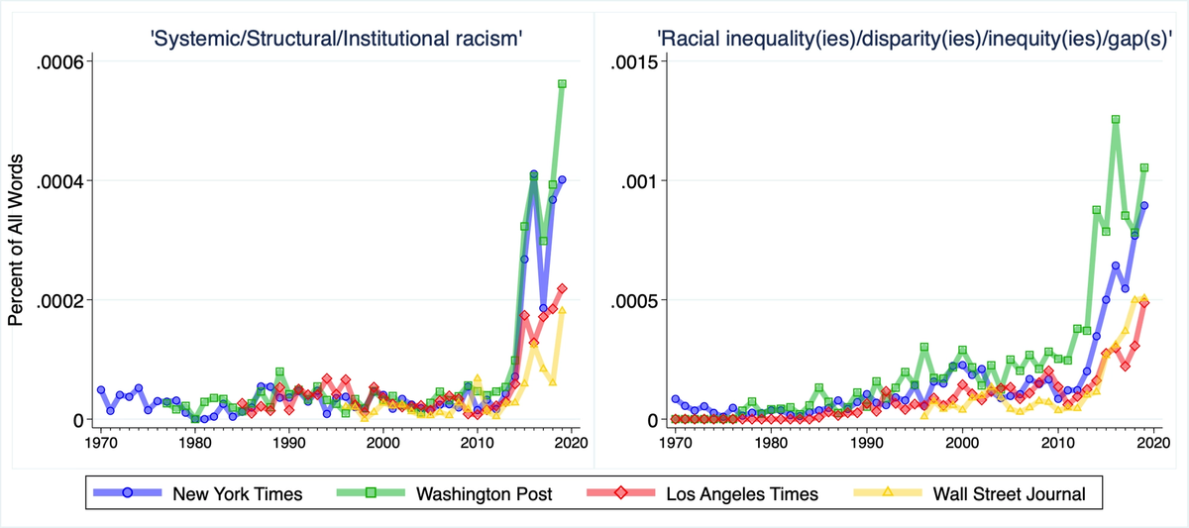
Why the sudden shift among white liberals? After we wrote our Atlantic essay in 2015, it became clear that politics was changing rapidly not only on campus, but off campus as well, and not just in the United States but in many liberal democracies that were being shaken by populist movements, particularly right-wing populism. Jon began to feel as if something had changed in the operating system of society; the old rules just didn’t seem to apply anymore. He began thinking that the change had something to do with the historically unprecedented increase in connectivity that had happened since the Internet became a global phenomenon in the late 1990s, or since social media platforms emerged around 2004. But if those were the culprits, then why didn’t things get weird back then? Why the sudden change around 2014?
It was only when Jon teamed up with the technology writer Tobias Rose-Stockwell that we found what we believe is the thing that warped the fabric of social space-time. It was the introduction of the “like” button, by Facebook, in 2009, which Twitter promptly copied, combined with the introduction of the “retweet” button by Twitter that same year, which Facebook copied in 2011. Before 2009, social media feeds were almost entirely chronological—content was mostly personal (rather than political) and social media was not particularly polarizing. But once users had two super-fast ways to say what they liked, and could do so many times a minute, the social media companies had vastly more information on each user’s behavior, and they began to optimize people’s newsfeeds using algorithms that continuously improved the platform’s ability to engage users and keep them clicking.
At first many thought this viral sharing could be a good thing for democracy, especially after a Facebook page in 2011 helped to start a revolution in Egypt that brought down a corrupt and brutal dictator in just a few weeks. But the rapid increase in public expressions of outrage—not just at murderous dictators but at young adult fiction writers, people who accidentally make the “OK” sign, fellow employees, fellow students who said something, professors who said something—at pretty much anyone at any time for almost any reason—this was the planetary change.
If not for these changes in social media that occurred during President Obama’s first term, we believe that America would not have lost its collective mind during Obama’s second term. Few of the witch hunts and other campus events that we described in The Coddling of the American Mind could have happened—it would have been hard to conduct rapid public shamings of professors and administrators for words or phrases embedded in well-intentioned emails. There would have been no Great Awokening in 2014, and no presidential campaign run on Twitter in 2016.
As former CIA analyst Martin Gurri has pointed out in his book Revolt of the Public, social media is adept at tearing down institutions, ideas, and even people, but so far has shown little ability to be constructive. Finding a way to harness the negative power of social media for positive ends will be a defining challenge for the next decade.

Monomania and Trumpism (On the Right)
Readers of our book might be surprised to know that almost all of the hate mail that we get about the book comes from readers on the right, not the left. They mainly accuse us of perpetuating the “Charlottesville Hoax,” which is the claim that Donald Trump called the white supremacists, neo-Nazis and KKK members of the 2017 Unite the Right Rally “very fine people.” The claim that this is a “hoax” relies on the fact that soon after in that same wild press conference, Trump mentioned, “I’m not talking about the neo-Nazis and the white nationalists—because they should be condemned totally.”
This seems like a good point to make against someone asserting that “Trump called neo-Nazis and white nationalists very fine people.” But that’s not what we wrote. We wrote: “With those three words—‘very fine people’—the president showed that he was sympathetic to the men who staged the most highly publicized march for racism and antisemitism in the United States in many decades.”
We watched all three press conferences carefully, multiple times, before we wrote what we wrote. In his remarks after the murder, his contemporaneous tweets, and even as recently as September 2021, Trump showed that he was sympathetic to the aims of the Unite the Right marchers: to oppose the removal of the statue of Robert E. Lee in Richmond, Virginia. But in the same remarks where he mentioned “very fine people,” Trump showed sympathy for the Unite the Right organizers, specifically, comparing them favorably to the counter-protestors by saying “you had a lot of people in that group that were there to innocently protest” and pointing out the pro-statue protestors “had a permit,”² unlike the counter-protectors. That permit was obtained, in fact, by prominent white nationalist and recurring Stormfront radio guest Jason Kessler. Trump also praised the protesters from “the night before,” perhaps trying to de-emphasize the Unite the Right protestors on the day of the violence. But the only documented protest in Charlottesville on August 11 was the march by neo-Nazis and white supremacists chanting “Jews will not replace us.”
Defenders of the “hoax” accusation like to claim Michelle Piercy as one of the kind of “good people” Trump mentioned. The New York Times reported that Piercy was “a night shift worker at a Wichita, Kan., retirement home, who drove all night with a conservative group that opposed the planned removal of a statue of the Confederate general Robert E. Lee.” While the article said that she “had no interest in standing with Nazis or white supremacists,” her organization, a heavily-armed militia group called American Warrior Revolution (AWR), served as a sort of self-appointed security force for a march that included Klansmen in full regalia, neo-Nazis with swastika signs, and numerous other white supremacist and antisemitic groups. But even assuming Piercy counts as a “very fine person," AWR was present at the August 12 event—not “the night before.”
So, even the people who say Trump called the white supremacists, KKK members, and neo-Nazis “very fine people” have a good argument. Trump may not have known who the people who got the permit were; he may have contradicted himself in that press conference; but nothing turns the claim that he complimented racist protesters into a “hoax.”
This reflexive, overzealous defense of Trump, especially at his worst moments, is part of a growing monomania on the right. Monomania means an exaggerated and unhealthy obsession with one thing. One strand of it is that Trump must be defended in all situations from criticism. The other strand could be simply stated as “anything to own the libs.” This becomes apparent on college campuses as well. Let’s consult the Scholars Under Fire database collected by Komi German and Sean Stevens at FIRE that was released in September (but is regularly updated, most recently on October 15). Of the 471 incidents we found of attempts to get professors fired, about 164 of them (35%) were from the right.
Indeed, among scholars targeted for sanction who also reported receiving threats (about 67 scholars) 60% of them said those threats came from their right rather than their left. Sadly, intimidation and harassment is very common online. To fully evaluate the nature of threats and who they come from would require a massive study of professors. We suspect there are thousands of examples of threats of physical violence against professors that have never been reported.
Sometimes when the conservative mob goes after professors, it misrepresents what those professors actually said. For example, Asheen Phansey, a former adjunct professor of business at Babson College, was investigated then fired for sarcastically tweeting that, in retaliation for former President Trump’s threat to target Iranian cultural sites, “Ayatollah Khomenei [sic] should tweet a list of 52 sites of beloved American cultural heritage that he would bomb,” including “Mall of America,” and the “Kardashian residence.” His tweet was somehow taken seriously, with one writer explaining that “[b]egging a religious lunatic who oppresses women and gay people to blow up American cultural sites is sadly par for the course for your run of the mill college professor in 2020, and likely will end with him getting tenure.”

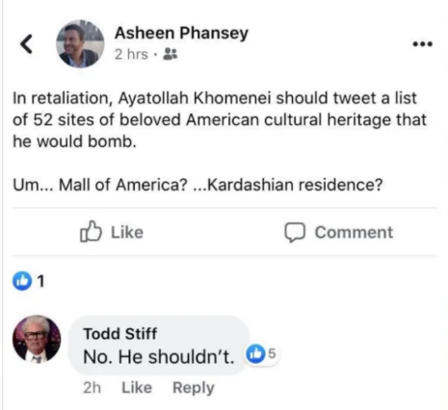

Sometimes the speech that gets professors in trouble is very unsympathetic but nonetheless protected by free speech and extramural academic freedom. For example, Fresno State University investigated a professor following a 10,000 signature petition calling for her firing for tweeting that Barbara Bush was an “amazing racist” who raised a “war criminal”, in response to news of her death. Like the case at Babson, FIRE was there to help the professor, but unlike at Babson, Fresno State did the right thing and dropped the investigation. Other professors—even ones with tenure—have not been so lucky. We count 27 professors with tenure fired since 2015.
The polarization spiral, which is fed and accelerated by social media, is making extremists on both right and left more extreme, more powerful, and more intimidating. Both sides feed off of each other. Both sides are essential for a polarization spiral. And that means that neither side can win by attacking or humiliating the other side. Such tactics only serve to energize the other side.

Jonathan Haidt, a member of the Persuasion advisory board, is a social psychologist at New York University’s Stern School of Business. He is a co-founder of Heterodox Academy.
Greg Lukianoff is a First Amendment lawyer and president and chief executive of FIRE, the Foundation for Individual Rights in Education.
Jon and Greg would especially like to thank Greg's Research Assistant Ryne Weiss for his excellent help with the research about the “Charlottesville Hoax.”
This piece was originally published in Persuasion on October 29, 2021.

Jon and Greg wrote an afterword for The Coddling of the American Mind in the summer of 2021 to be added to a second edition of the book in 2022, but it grew so long that it would have raised the page count and cost of the book substantially. Instead, the nine sections of the afterword will be released in nine parts. The first three parts were published by the Foundation for Individual Rights in Education (FIRE), and are linked below. In this latest part, the authors discuss the post-2014 Great Awokening on the left and the dangers of monomania on the right. Sections from the new afterword to The Coddling of the American Mind previously published by FIRE:
- Part 1: Gen Z’s Mental Health Continues to Deteriorate
- Part 2: It’s Social Media — More Than Screen Time — That Matters for Mental Health
- Part 3: Increasing Persecution on Campus

“But you had a lot of people in that group that were there to innocently protest, and very legally protest—because, I don’t know if you know, they had a permit. The other group didn’t have a permit. So I only tell you this: There are two sides to a story. I thought what took place was a horrible moment for our country—a horrible moment. But there are two sides to the country.”

